

NDP MIS: Intermediate Phase
Amendments of Business and Project Plans

Table of Contents
1.1 BACKGROUND 2
1.2 Methodology 2
1.3 Screen changes 2
1.4 Rules 3

BACKGROUND
The NDP has completed the first phase of its MIS development. Small improvements and enhancements as well as error fixing will now be the focus for the next 2 months.
The NDP has a requirement to be able to amend the Business and Project plans on the MI after it has been approved. This can be for a number of reasons:
- An increase in the scope of the business or project plan
- An increase or decrease in the value of the business or project plan
- Errors on the previous document

METHODOLOGY
After and agreement between the Project director and the municipality, the project director views the current approval screen for the applicable document on MIS. The project director then selects the field named:
‘Amend Business plan?’ Y/N Reason: drop down list with reasons as above
After selecting this field, the applicable business or project plan reverts back to an editable document and can be amended as required. This also creates a new version of the document.
The status then reverts to ‘submitted and not approved’
The process follows the same methodology as for a first approval and hence the assessment document is completed, thereafter the ‘ready for assessment’ field is selected and the assessment and approval process follows.

SCREEN CHANGES
The following changes needs to be made to the screens:
On the approval screen: a new field with the new approval value is shown, as follows:
Total revised NDP ceiling for this business plan / project plan
R- value
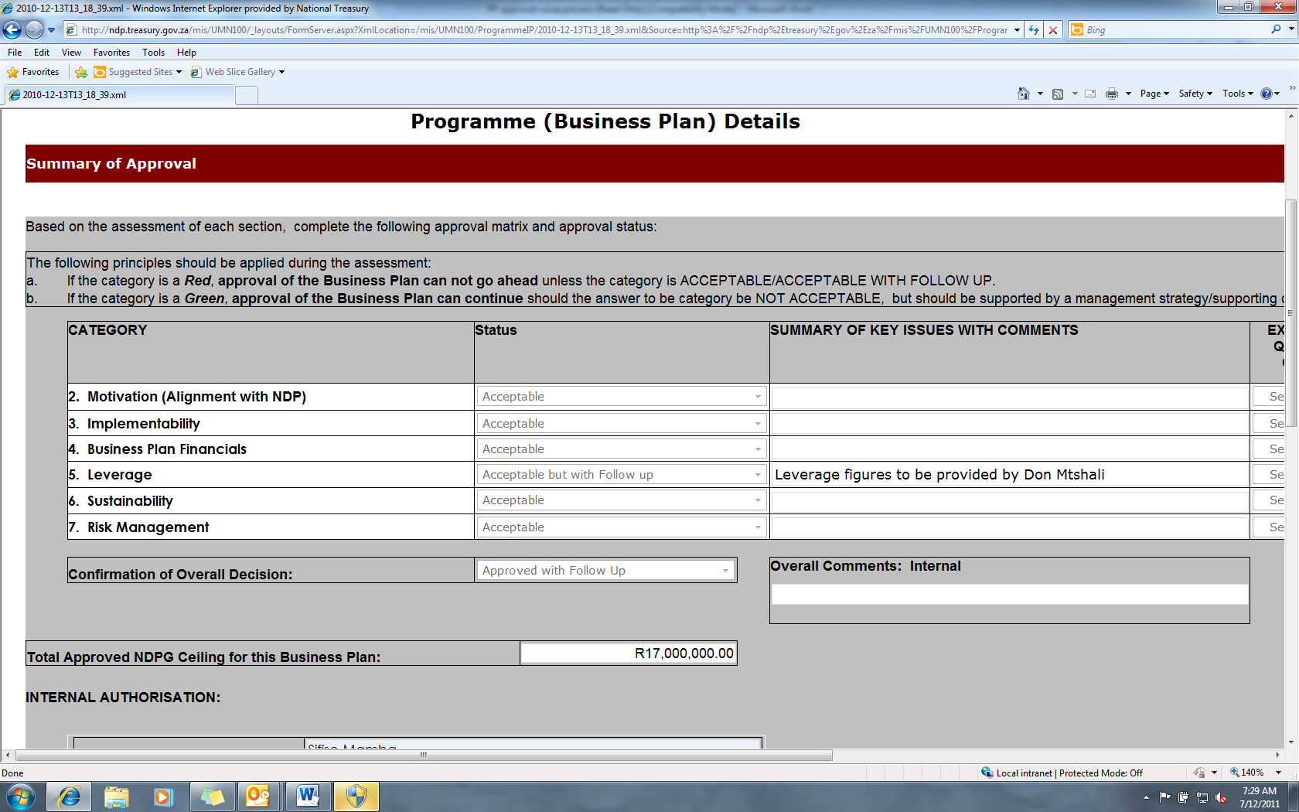

The business plan / project approval value is the only value that is reported on and shown on the landing page. The final assessment value is only used as a motivation for this value.
For every amendment to the approved business / project plan, a new approval ceiling block is added as shown above.

RULES
The following business and process rules are applicable:
- This is an internal process only and will not be open to the municipalities.
- Any amendments can be made to the document during the recapture phase

